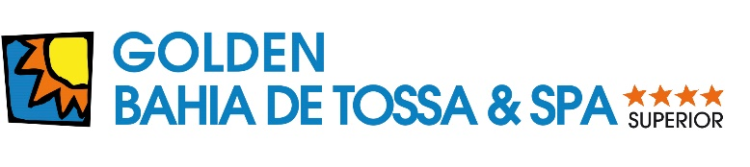

|  |  |
| --- | --- |
| Resultado de imagen de bandera inglesaSPA & BEAUTYSPA CENTER 6 EUROS – 1 hour | |
| MASSAGES |  |
| **MASSAGE** localized (20 Min.) relax, or stimulating, or circulatory on the legs  **MASSAGE** (30 Min.) w. essential oils  **MASSAGE** full body (45 Min.) relax, or stimulating  **HEAD & FACE MASSAGE** (20 Min.)  **CONTRACTURES RELIEVE MASSAGE** w. mud or electric muscle stimulation + infrared  **ANTICELLULITE MASSAGE** localized (20')+ pressotherapy(30' Min.)  **DEEP TISSUE MASSAGE** manual massage (45') + infrared lamp + electric muscle stimulation  **KINESIOTAPE** Zonal acupuncture + tape | **28 €**  **42 €**  **52 €**  **28 €**  **51 €**  **55 €**  **56 €**  **25 €** |
| **MASSAGES OF THE WORLD** |  |
| **SHIATSU** Japanese therapy activating body’s energetic channels (45 Min.)  **BALINESE MASSAGE** relaxing with stretches (45 Min.)  **TURKISH BATH** Steam bath +Massage + deep skin exfoliation with real black soap (75' Min.)  **GEOTHERMAL** Massage with warm volcanic stones (45 Min.)  **ESSENCE OF POLINESIA** exfoliation and massage with sea shells (60 min.)  **VICHY TREATMENT** energetic Massage with water, sesame oil and Scottish shower (45 min.)  **SABAI THAI MASSAGE** herbs hidromassage bath (20') and massage (30') | **56 €**  **51 €**  **59 €**  **52 €**  **64 €**  **51 €**  **52 €** |
| **REVITALIZING TREATMENTS** |  |
| **LYMPHATIC DRAINAGE** manual, full body(45 Min.)  **REFLEXOLOGY** (30 Min.)  **PRESSOTHERAPY** (30 Min.)  **BODY PEELING** | **49 € 34 € 32 € 37 €** |
| ESPECIAL PACKS |  |
| **MASSAGE (20 Min.)** 4 Sessions  **MASSAGE (30 Min.)** 4 Sessions  **MASSAGE (20 Min.) + REFLEXOLOGY**  **FACIAL CLEANSING + MASSAGE** (20 Min.)  **PRESSOTHERAPY** 4 Sessions + 1 SPA de regal | **101 €**  **151 €**  **56 €**  **78 €**  **116 €** |
| **TREATMENTS FACIALS** |  |
| **FACIAL CLEANSING “GOLDEN BAHIA”**  **ANTI- AGE TREATMENT**  **FACIAL KOBIDO** Express facial cleansing + japanese face massage KOBIDO  **FACIAL LIFTING w. ACUPUNTURE**  **FACIAL REFLEXOLOGY**  **FACIAL TREATMENT W. CARBON AND ROSES** | **59 €**  **62 €**  **55 €**  **64 €**  **57 €**  **60 €** |
| **BODY TREATMENTS** |  |
| **SEA WEED, MUD, OR CHOCOLATE TREATMENTS**  With Sauna or steam bath hydromassage bath, exfoliation, therapeutic wrapping and cream  **COFFEE TREATMENT** body and facial | **73 €**  **79 €** |
| **EPILATION** |  |
| **HALF LEGS** **FULL LEGS****INTIMATE PACK (BIKINI LINE + UNDERARMS)****FACIAL PACK (EYEBROWS + UPPER & UNDER LIP)****ARMS** **EPILATION FOR MEN ask in reception** | **21 €**  **29 €**  **25 €**  **18 €**  **19 €**  **------** |
| **MANICURES AND PEDICURES** |  |
| **MANICURE**  **SPA MANICURE** with peeling, mask and massage  **LONG LIFE MANICURE** with semi-permanent gel lacquer **PEDICURE** **SPA PEDICURE** with peeling, mask and massage  **LONG LIFE PEDICURE** with semi-permanent gel lacquer | **22 €**  **35 €**  **35 €**  **35 €**  **45 €**  **45 €** |
| **OTHER SERVICES** |  |
| **PERMANENT MAKE-UP** **HYDROMASSAGE BATH** | **200€**  **15 €** |